FBLA Goes Green: Individual
California FBLA State Project
Project Deadline: December 22, 2011
Environmental cognizance is integral to global health
and success, and as the business leaders of tomorrow,
it is our responsibility to propagate awareness about
ecological issues and actively engage ourselves in the
quest to reduce our carbon footprints on the world.

Individual Project Guidelines
It’s time for California FBLA to foster a greener community and dramatically decrease its carbon footprint on the world. For more information about what you can do, go to www.seegreennow.com, www.climatecrisis.net, www.stopglobalwarming.org, or www.localcooling.com.
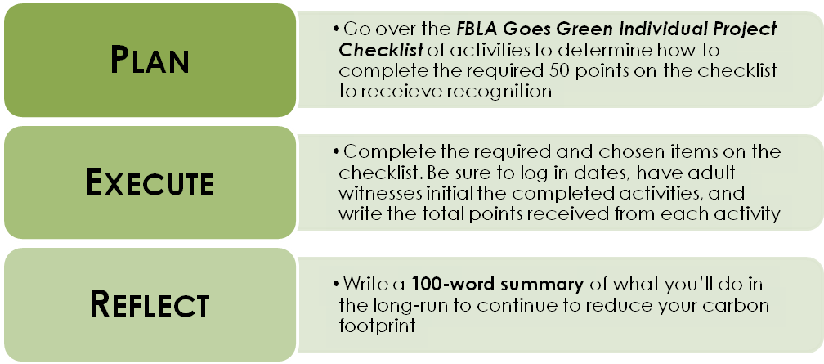
Questions? Please contact Jennifer Stalley, the California FBLA State Officers' Adviser, at stateofficersadviser@cafbla.org.
Name:___________________________________ School:___________________________________
FBLA Goes Green
Individual Project Checklist (Page 1)

Activity | Requirements | Date(s) | Initials of Adult Witness | Points
REQUIRED  ACTIVITY  Informational Flyer | Develop and attach an informational flyer to spread awareness about global warming
CHANGE A LIGHT  You’ll save: 150 lbs. of CO₂ a year!  Max Points: 5 | Change light bulbs to fluorescent lights in your house or at school. Log 1 point for each light bulb changed  Attach pictures of the new light bulbs
DRIVE LESS  You’ll save: 1 lb. of CO₂ for every mile you don’t drive!  Max Points: 10 | Log 2 points for each day you carpool, walk, or bike to school  Include initials of adult witness for each date
RECYCLE MORE  You’ll save: 2,400 lbs. of CO₂ per year by recycling half your household waste!  Max Points: 10 | Log 1 point for every pound of glass, plastic, paper, ink cartridges, shoes, and batteries you recycle  Attach a receipt from the recycling center
BUY LOCALLY GROWN PRODUCTS  You’ll save: 1,200 lbs. of CO₂ each year!  Max Points: 9 | Log 3 points for every $10 you spend on products  Market Name:_____________________  Types of Products:__________________  Attach a picture of you with your purchase
UNPLUG ELECTRONICS  You’ll save: 1,000 lbs. of CO₂ each year!  Max Points: 5 | Use a power strip to organize all of your plugs and turn it off each night before you sleep  Attach a picture of you with your new power saver
GROW A GARDEN  You’ll save: 2 lbs. of CO₂ for every lb. of fruits or vegetables you grow yourself!  Max Points: 5 | Put your green thumb to work; This growing season, plant and tend your own garden!  Attach a picture of you with your new garden
Point Subtotal For Page 1:________
Name:___________________________________ School:___________________________________
FBLA Goes Green

Individual Project Checklist (Page 2)
Activity | Requirements | Date(s) | Initials of Adult Witness | Points
ADJUST YOUR THERMOSTAT OR REDUCE YOUR WATER USAGE  You’ll save: over 2,000 lbs. of CO₂ each year!  Max Points: 10 | Make a commitment to reduce your home heating/cooling costs or water usage costs for a month in your home. If the next month you reduce costs by 10%, add 5 points  Attach your energy bills or water bills for proof of reduction
PLANT A TREE  You’ll save: 5,000 lbs. of CO₂ a year!  Max Points: 10 | Add 5 points for each tree you plant  Attach a picture of you planting the tree
ORGANIZE A MOVIE NIGHT  Spread awareness by showing movies about global warming and solutions!  Max Points: 10 | Name of Film: _____________________  Date & Time:_______________________  Location:__________________________  Number Attending:________________  Attach a 100-word summary about what you learned from the film, and attach a picture of attendees watching the film
PARTICIPATE IN  A LOCAL  “GO GREEN” EVENT  Max Points: 10 | 5 points per event  Attach a 100-word summary about the event, and include pictures of you there
WRITE A LETTER  Max Points: 10 | 2 points per letter  Write a letter to a local business with a specific suggestion about going green that must be signed by both the member and the local chapter adviser.  Attach a copy of each letter sent

Point Subtotal For Page 2:________

Name:___________________________________ School:___________________________________
FBLA Goes Green

Individual Project Checklist (Page 3)
Activity | Requirements | Date(s) | Initials of Adult Witness | Points
CONVINCE A TEACHER TO GO PAPERLESS FOR 1 WEEK  You’ll save: trees!  Max Points: 10 | Teacher’s Name: __________________  Teacher’s Signature:_______________
PURCHASE BIODEGRADABLE ALTERNATIVES  You’ll prevent harmful chemicals damaging the soil!  Max Points: 10 | For every $10 spent, add 5 points, and attach a receipt of the purchase
USE A RESUSEABLE WATER BOTTLE  You’ll avoid unnecessary waste in landfills!  Max Points: 3 | Must be signed by adviser  Adviser’s Signature:________________  Attach a picture of you with your water bottle
LEARN ABOUT ALTERNATIVE FUELS  Max Points: 5 | Write and attach at least one page on one type of alternative fuel
JOIN A MAILING LIST  Max Points: 2 | Attach an email from the environmental organization
PURCHASE GREEN CLEANING SUPPLIES  Help improve indoor air quality!  Max Points: 8 | Add 2 points for each green cleaning supply you purchase  Attach receipts of purchased items
REQUIRED  ACTIVITY  Summary | Attach a 100-word summary of what you’ll do in the long run to continue to reduce your carbon output

Total Project Points:________
Minimum amount required for Recognition: 50

